DRIFT ATTACK
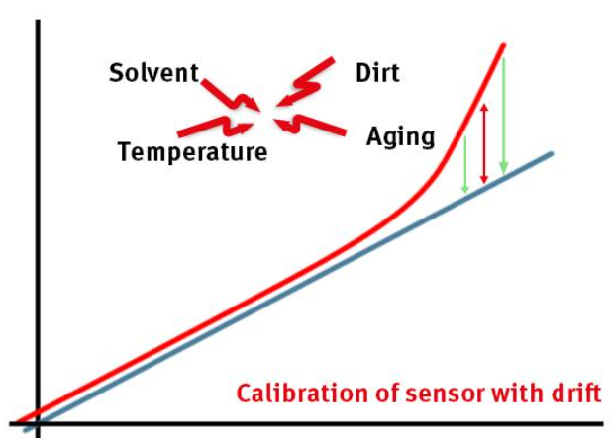

“Drift attack shows a consistent directional trend, captured using slope-based features.”

THEORY
Drift = slow, consistent change in one direction
- Temperature gradually ↑ or ↓
- Looks normal initially
- Becomes abnormal over time

HOW TO IDENTIFY
Look for:
✔ Smooth curve
✔ Consistent direction
✔ No sudden jumps
✔ Long duration
🔍 EXAMPLE
24.1 → 24.3 → 24.6 → 25.0 → 25.5 → 26.0

INJECTION ATTACK (SPIKE)
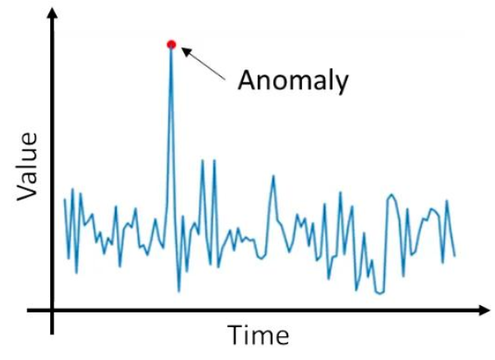
“Injection attack is detected using range and spike magnitude.”

THEORY
Injection = sudden abnormal value injected
- Sharp spikes or drops
- Very short duration

HOW TO IDENTIFY
✔ Sudden jump
✔ Outlier point
✔ Returns to normal quickly

EXAMPLE
24.5 → 24.6 → 30.0 → 24.7

DROP ATTACK (FREEZE)

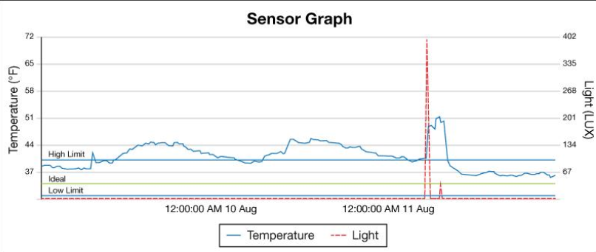
“Drop attack is identified using very low standard deviation.”

THEORY
Drop = sensor stops changing (stuck value)
- Flat line
- No variation

HOW TO IDENTIFY
✔ Same value repeated
✔ Very low variance
✔ No movement

EXAMPLE
25.0 → 25.0 → 25.0 → 25.0

NOISE ATTACK

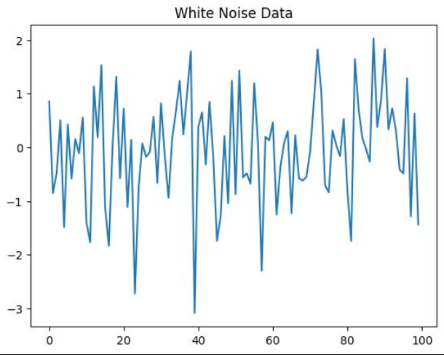
“Noise attack increases entropy and variance significantly.”
THEORY
Noise = random chaotic variation
- High fluctuation
- No clear pattern

HOW TO IDENTIFY
✔ Zig-zag pattern
✔ High variance
✔ Unstable values

EXAMPLE
24 → 27 → 23 → 28 → 22 → 26

REPLAY ATTACK

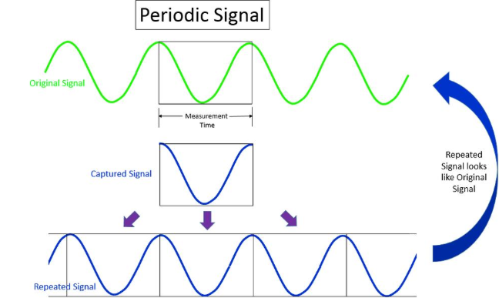
Replay attack is detected using similarity comparison across time windows

THEORY
Replay = old data repeated later
- Same pattern appears again
- Time-shifted duplication

HOW TO IDENTIFY
✔ Repeating sequence
✔ Similar shape earlier in graph
✔ Not random

EXAMPLE
Block1: 24 → 25 → 26 → 25
Block2: 24 → 25 → 26 → 25 (later time)

